Tutorial 20 Glow and Flares

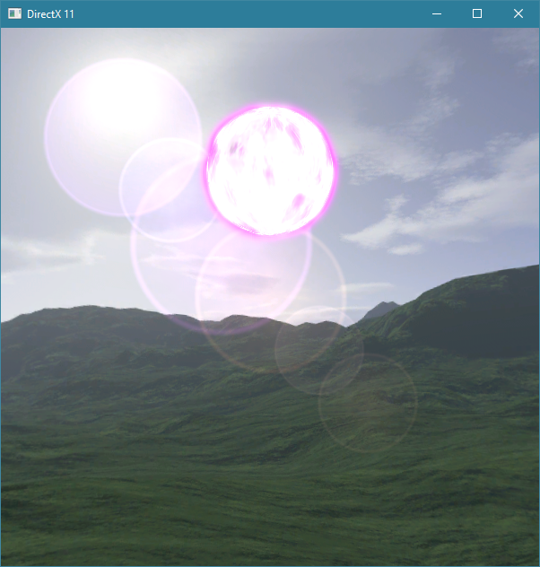

- Create the shader resource view of the depth buffer(System.cpp)
// Setup the description of the shader resource view
D3D11_SHADER_RESOURCE_VIEW_DESC shaderResourceViewDesc;
shaderResourceViewDesc.Format = DXGI_FORMAT_R24_UNORM_X8_TYPELESS;
shaderResourceViewDesc.ViewDimension = D3D11_SRV_DIMENSION_TEXTURE2DMS;
shaderResourceViewDesc.Texture2D.MostDetailedMip = 0;
shaderResourceViewDesc.Texture2D.MipLevels = 1;

- Add a flare vertex struct (VertexStructures.h):
struct FlareVertexStruct {
DirectX::XMFLOAT3 pos;
DirectX::XMFLOAT3 posL;
DirectX::PackedVector::XMCOLOR colour;
};

- And Vertex Descriptor:

// Vertex input descriptor based on Flare VertexStruct
static const D3D11_INPUT_ELEMENT_DESC flareVertexDesc[] = {
{ "POSITION", 0, DXGI_FORMAT_R32G32B32_FLOAT, 0, 0, D3D11_INPUT_PER_VERTEX_DATA, 0 },
{ "LPOS", 0, DXGI_FORMAT_R32G32B32_FLOAT, 0, 12, D3D11_INPUT_PER_VERTEX_DATA, 0 },
{ "COLOR", 0, DXGI_FORMAT_R8G8B8A8_UNORM, 0, 24, D3D11_INPUT_PER_VERTEX_DATA, 0 }
};

- Add an array of flare pointers to Scene.h
static const int numFlares = 6;
Flare *flares[numFlares];

- In scene.cpp add a pointer to an Effect and create flare effect
Effect *flareEffect = new Effect(device, "Shaders\\cso\\flare_vs.cso", "Shaders\\cso\\flare_ps.cso", flareVertexDesc, ARRAYSIZE(flareVertexDesc));

- Modify flare effect blend state

ID3D11BlendState *flareBlendState = flareEffect->getBlendState();
D3D11_BLEND_DESC blendDesc;
flareBlendState->GetDesc(&blendDesc);
blendDesc.AlphaToCoverageEnable = FALSE;
blendDesc.RenderTarget[0].BlendEnable = TRUE;
blendDesc.RenderTarget[0].SrcBlend = D3D11_BLEND_ONE;
blendDesc.RenderTarget[0].DestBlend = D3D11_BLEND_ONE;
// Create custom flare blend state object
flareBlendState->Release(); device->CreateBlendState(&blendDesc, &flareBlendState);
flareEffect->setBlendState(flareBlendState);

- Copy flares folder to resources//textures

